
Touchstones Project
Netcards

Circle of Life Netcards with Text

Baby HRJ
Beginning HRJ
Bread HRJ
Childhood HRJ

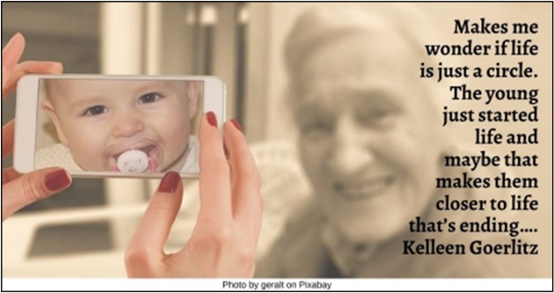

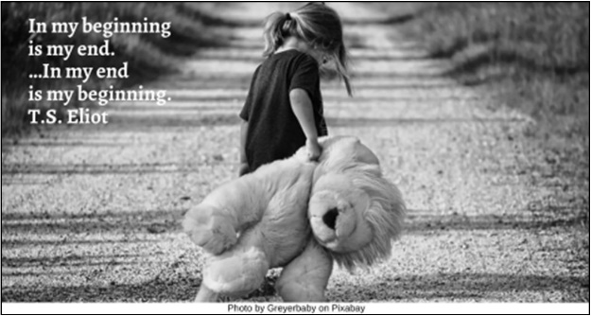

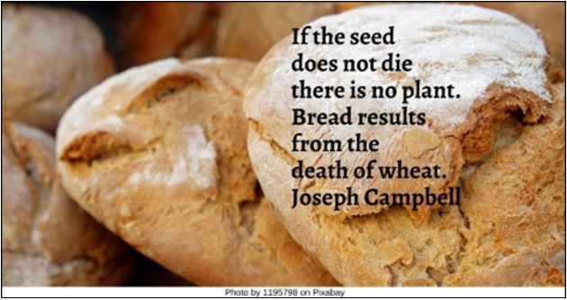

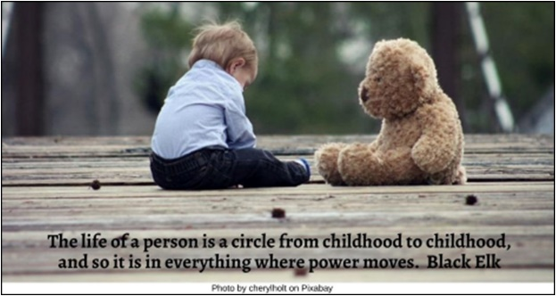

Circle HRJ
Circle of people HRJ
Circles within circles HRJ
City HRJ

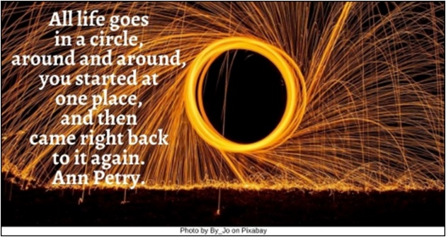

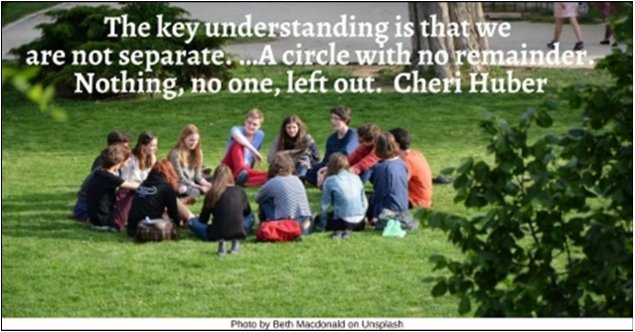

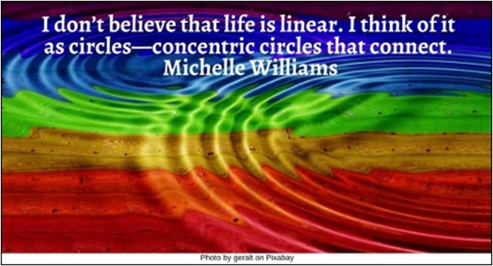

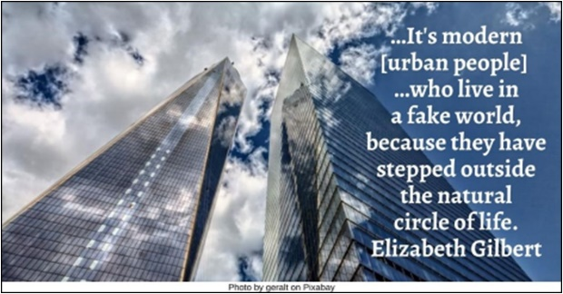

Compassion HRJ
Dancing on Beach HRJ
Dawn HRJ
Eagle HRJ

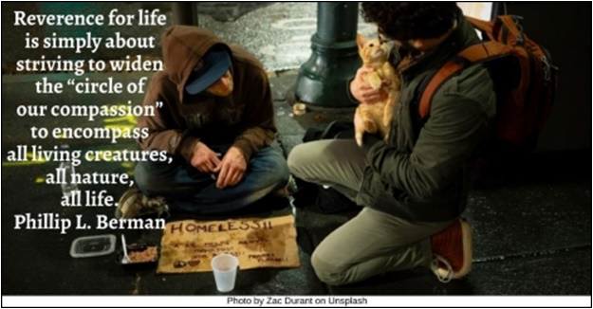

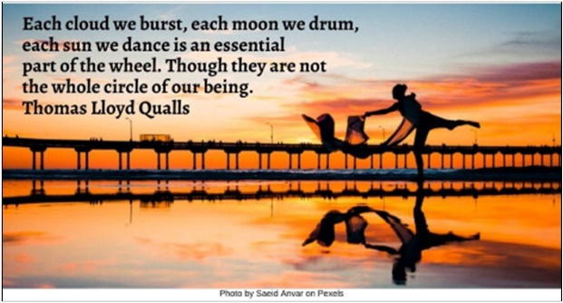

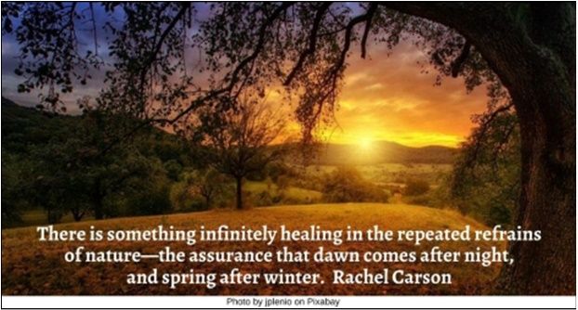

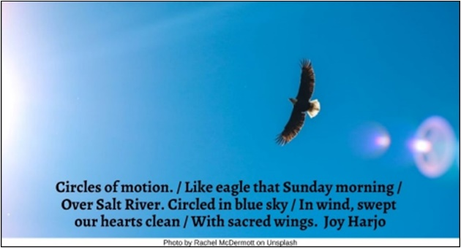

Earth HRJ
Ensō HRJ
Falling Leaf HRJ
Hiker HRJ

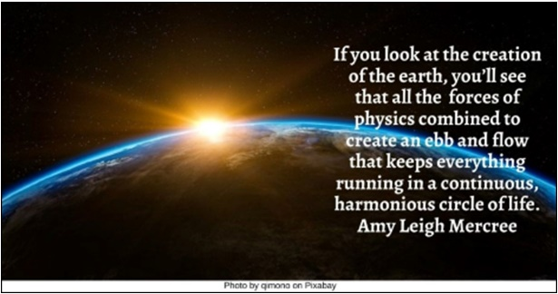

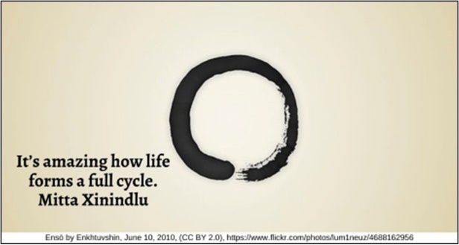

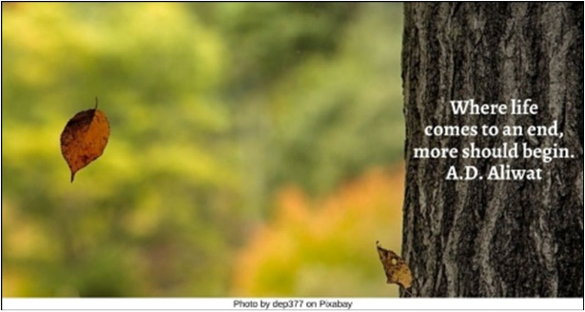

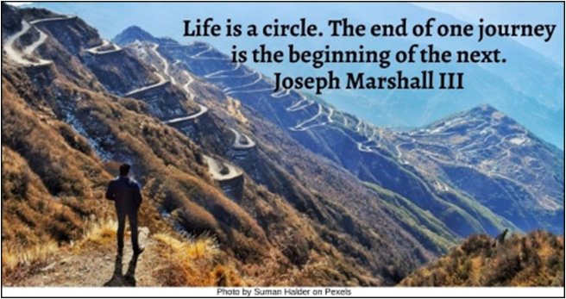

Hunter HRJ
Imperfect HRJ
Infinity HRJ
Leopard cub HRJ

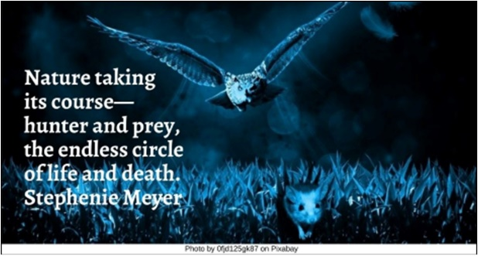

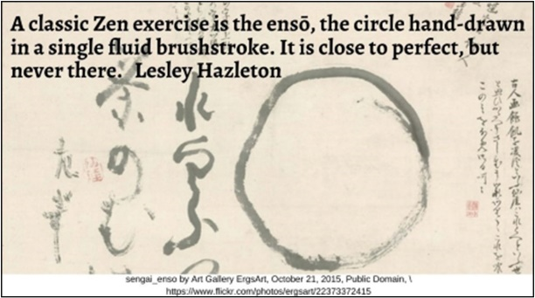

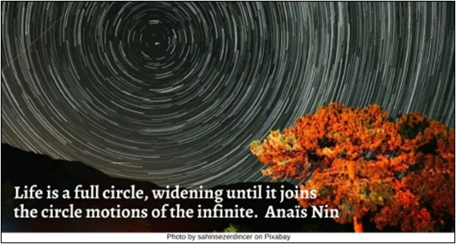

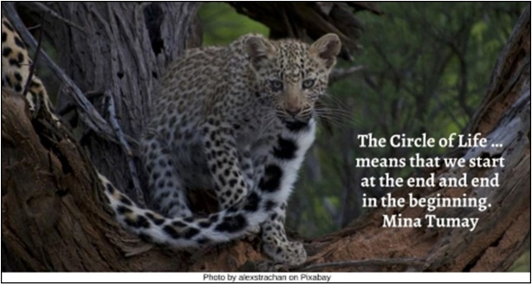

Meditation HRJ
Ripples in water HRJ
Seasons HRJ
Sharing HRJ

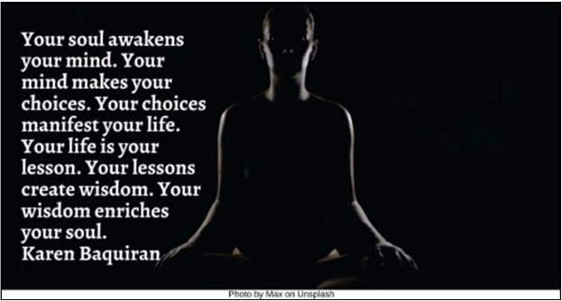

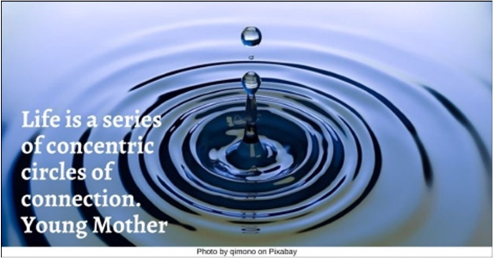

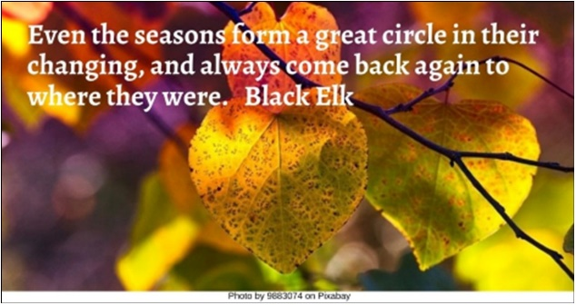

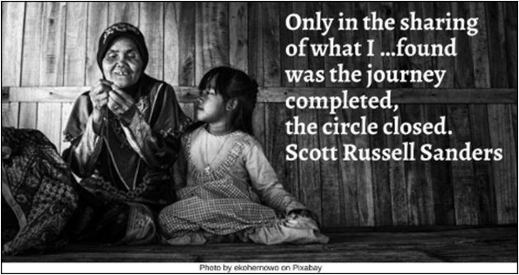

Side by side HRJ
Stars HRJ
Story HRJ
Tomorrow HRJ

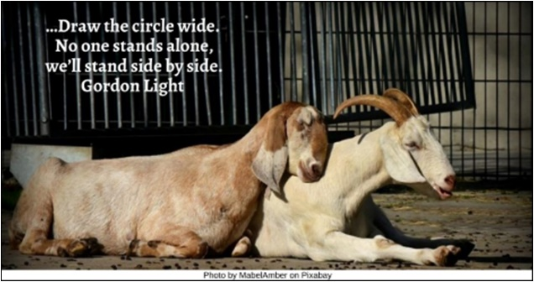

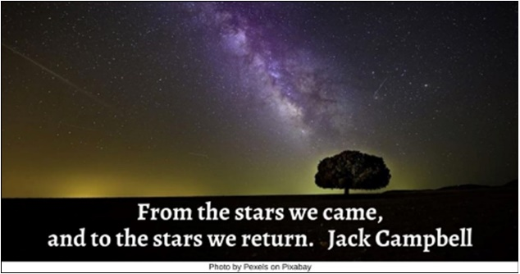

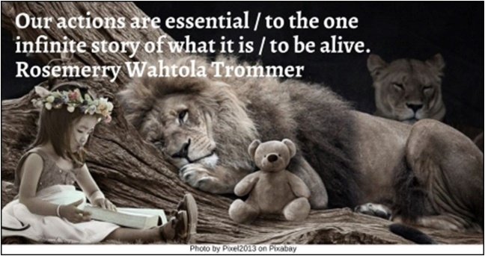

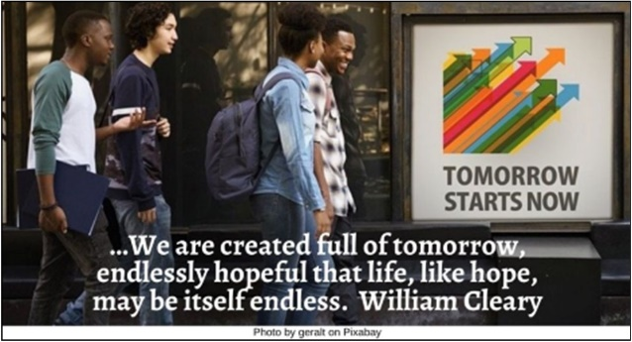

Web HRJ
Wheel of Life HRJ
Widening circles HRJ

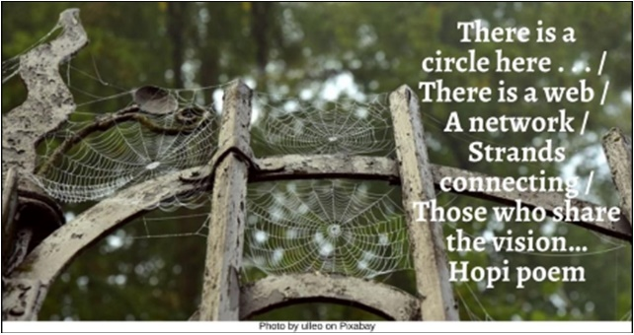

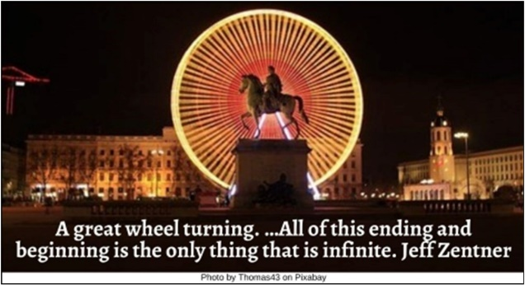

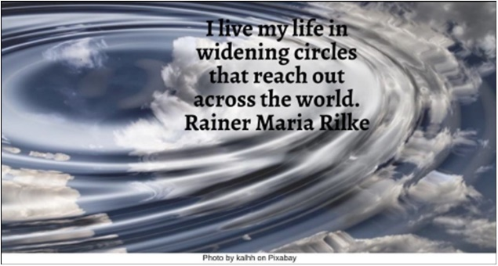

Text of Quotes
Baby HRJ
Makes me wonder if life is just a circle. The young just started life and maybe that makes them closer to life that’s ending…. Kelleen Goerlitz

Beginning HRJ
In my beginning is my end. …In my end is my beginning. T.S. Eliot

Bread HRJ
If the seed does not die there is no plant. Bread results from the death of wheat. Joseph Campbell

Childhood HRJ
The life of a person is a circle from childhood to childhood, and so it is in everything where power moves. Black Elk

Circle of people HRJ
The key understanding is that we are not separate. …A circle with no remainder. Nothing, no one, left out. Cheri Huber

Circle HRJ
All life goes in a circle, around and around, you started at one place, and then came right back to it again. Ann Petry.

Circles within circles HRJ
I don’t believe that life is linear. I think of it as circles—concentric circles that connect. - Michelle Williams

City HRJ
…It's modern [urban people] …who live in a fake world, because they have stepped outside the natural circle of life. Elizabeth Gilbert

Compassion HRJ
Reverence for life is simply about striving to widen the “circle of our compassion” to encompass all living creatures, all nature, all life. Phillip L. Berman

Dancing on Beach HRJ
Each cloud we burst, each moon we drum, each sun we dance is an essential part of the wheel. Though they are not the whole circle of our being. Thomas Lloyd Qualls

Dawn HRJ
There is something infinitely healing in the repeated refrains of nature—the assurance that dawn comes after night, and spring after winter. Rachel Carson

Eagle HRJ
Circles of motion. / Like eagle that Sunday morning / Over Salt River. Circled in blue sky / In wind, swept our hearts clean / With sacred wings. Joy Harjo

Earth HRJ
If you look at the creation of the earth, you’ll see that all the forces of physics combined to create an ebb and flow that keeps everything running in a continuous, harmonious circle of life. Amy Leigh Mercree

Ensō HRJ
It’s amazing how life forms a full cycle. Mitta Xinindlu

Falling Leaf HRJ
Where life comes to an end, more should begin. A.D. Aliwat

Hiker HRJ
Life is a circle. The end of one journey is the beginning of the next. Joseph Marshall III

Hunter HRJ
Nature taking its course—hunter and prey, the endless circle of life and death. Stephenie Meyer

Imperfect HRJ
A classic Zen exercise is the ensō, the circle hand-drawn in a single fluid brushstroke. It is close to perfect, but never there. Lesley Hazleton

Infinity HRJ
Life is a full circle, widening until it joins the circle motions of the infinite. Anaïs Nin

Leopard cub HRJ
The Circle of Life …means that we start at the end and end in the beginning. Mina Tumay

Meditation HRJ
Your soul awakens your mind. Your mind makes your choices. Your choices manifest your life. Your life is your lesson. Your lessons create wisdom. Your wisdom enriches your soul. Karen Baquiran

Ripples in water HRL
Life is a series of concentric circles of connection. Young Mother

Seasons HRJ
Even the seasons form a great circle in their changing, and always come back again to where they were. Black Elk

Sharing HRJ
Only in the sharing of what I …found was the journey completed, the circle closed. Scott Russell Sanders

Side by side HRJ
…Draw the circle wide. No one stands alone, we’ll stand side by side. Gordon Light

Stars HRJ
From the stars we came, and to the stars we return. Jack Campbell

Story HRJ
Our actions are essential / to the one infinite story of what it is / to be alive. Rosemerry Wahtola Trommer

Tomorrow HRJ
…We are created full of tomorrow, endlessly hopeful that life, like hope, may be itself endless. William Cleary

Web HRJ
There is a circle here . . . / There is a web / A network / Strands connecting / Those who share the vision… Hopi poem

Wheel of Life HRJ
A great wheel turning. …All of this ending and beginning is the only thing that is infinite. Jeff Zentner

Widening circles HRJ
I live my life in widening circles / that reach out across the world. Rainer Maria Rilke

